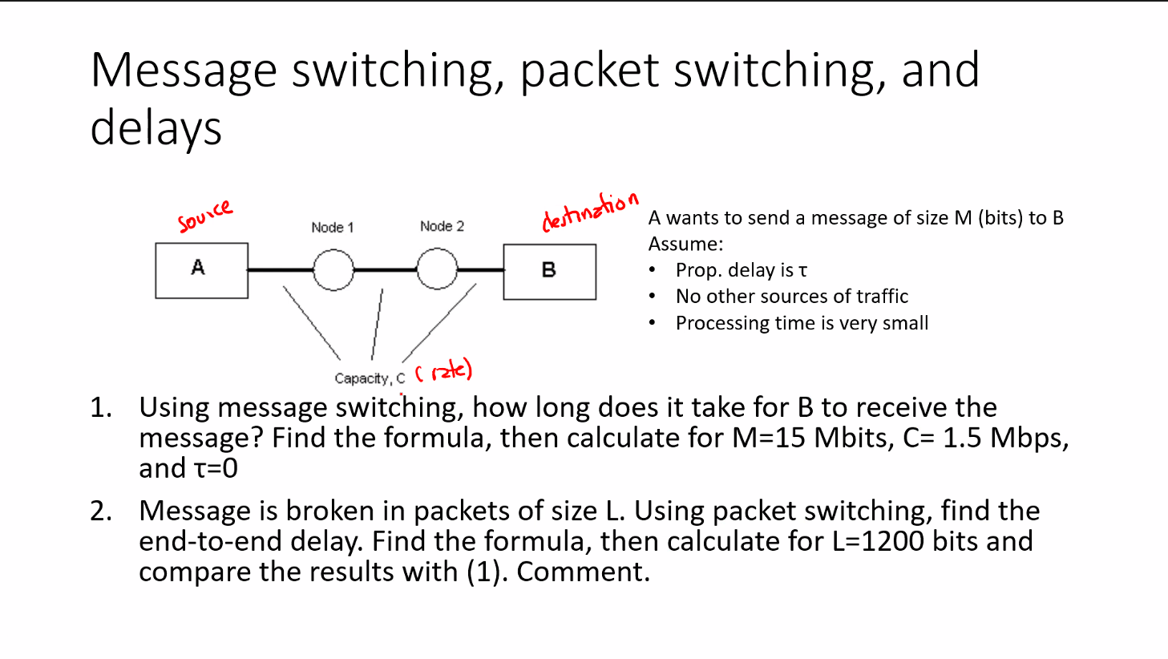

1. 3(M/C + t) = 3 \* (15 / 1.5 + 0) = 30 seconds?
2. (P + N – 1)\*(L/C + t) = ~10 seconds

